**Component, Deployment and Collaboration diagrams for Online Shopping**

Component Diagram for Online Shopping

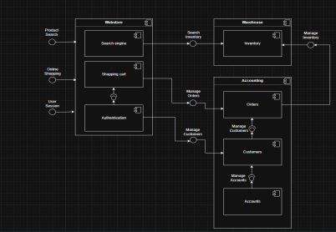

Deployment Diagram for Online Shopping

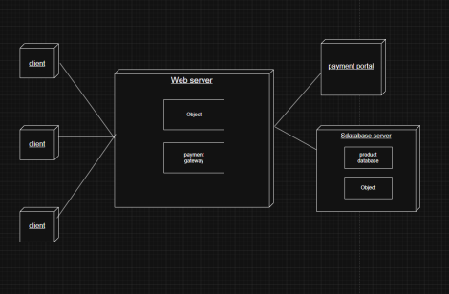

Collaboration Diagram for Online Shopping

